**Lab 1**

In this week, we practice drawing flowcharts to know how to design a resolution strategy in order to solve the problem by computer. Students can see some sample exercises and must prepare solutions for all exercises in part B.

**A. Sample exercises.**

1. Design an algorithm in flowchart to read and find maximum between 2 numbers.

**Solutions:**

Prototype: Max(float x, float y)

Flowchart:

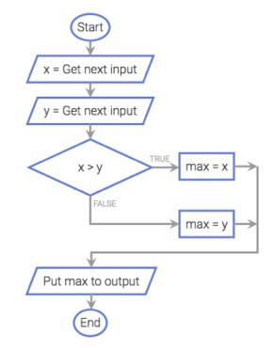

**Figure 1. Determine maximum between 2 numbers**

1. Design an algorithm in flowchart to convert between meters and inches.

(Hint: 1 inch = 2,54 cm).

**Solutions:**

Prototype : *floatconvert (float a,int sel);*

//*sel*=1: inches to meter, *sel* ≠1: meter to inches

Flowchart :



**Figure 1. Converter between meters and inches**

1. Design an algorithm in flowchart to calculate the diameter, circumference, and area of the circle of radius *R*.

**Solutions:**

Prototype : *CircleDetail (float R);*

Flowchart :





**B. Exercises must to do.**

1. Design an algorithm in flowchart to find the smallest number in a group of three real numbers.
2. Design an algorithm in flowchart to check whether a point *A(x, y)* is on, inside or outside the circle with center *O(x0, y0)* and radius of size *R*.
3. Design an algorithm in flowchart to solve the quadratic equation: ax2 + bx + c =0 with the inputs *a*, *b*, and *c*.
4. Design an algorithm in flowchart to read in a group of *N* numbers and compute the average of them, where *N* is also an input.
5. Design an algorithm in flowchart to determine if a triangle is **equilateral, isosceles, right-angled or isosceles** **right-angled triangle** when a,b,c - the lengths of three sides of this triangle - are given.
6. Design an algorithm in flowchart to calculate the average of four grades of four subjects of a student and determine whether students “Pass” (>=60) or “Fail”.

**C. Exercises in advanced.**

1. A set of linear equations:

aX + bY = c

dX + eY = f

can be solved using Cramer’s rule as:

X = (ce – bf)/(ae – bd)

Y = (af – cd)/(ae – bd)

Design an algorithm in flowchart to read in *a, b, c, d, e* and *f* and then solve for *X* and *Y*.

1. Design algorithm to check if a given year is leap year or not.(Leap year is divisible by 4 but not by 100 or divisible by 400.)

Hint: leap year is the year divisible by 4 but not divisible by 100, or it is divisible by 400.

1. Design an algorithm in flowchart to read and calculate factorial of integer N.